Task 3: Reflective Thinking and Generative Conversation
Institution
Course
Name

.

System Assumptions and Beliefs
There is uniformity of the beliefs and assumptions within the charter network that I teach across all schools and grade levels. The assumptions that are reached for in this case exist as an underlying set of shared convictions that can only be explained through the values and artifacts that are employed in the day-to-day routines throughout the school. There exist three levels of culture: artifacts and creations, values, and basic assumptions. For me to be in a position to point out the culture of my school, I went through these three levels; the artifacts, values, and assumptions (Senge & Dutton, 2012). To start with, the pieces of evidence that can be found in the daily structures entails a sense of visible support and teamwork. The school has set up a sports department, but it is not doing fair enough to ensure that it functions as anticipated. During any given day, the department of sport seems to be trying to provide its support services concerning ensuring each of the students is involved in the play. This involves acquiring all the necessary play materials and ensuring that the necessary structures such as swings are put up. Each class is assigned a teacher who accompanies them to the field. At times it is necessary to have a teacher watching over the students while in the field. Besides, the school integrates some practices that make it possible for all students to communicate in their native language and their cultures are recognized and celebrated within the physical environment. Such visible artifacts are due to the values and assumptions that are reached for at my school.
The school always considers data in times of reaching for decisions regarding plans and coaching. This is a shared growth mindset that seems to be accepted and practiced amongst all those involved in physical activities around the school. There seems to be a common goal of letting the students carry on with the kind of play that excites them. The school is set up in an area where students do not have to walk to school – the place does not allow them to take part in such physical activities. Thus, the majority of the families prioritize their children taking part in physical exercises while at school.
Analyzing Mental Models
An inquiry into mental models and beliefs of all people helps one to become an agent for change. In efforts to implement any kind of new intervention plan in pre-K and kindergarten levels, I would have to bring all interested stakeholders onboard. I will also have to ensure there is a continuous ongoing meeting that will enable us to have reflections, questions, and feedback concerning our progress. In efforts to kick-off the process, I would advocate my new idea during the first meeting where are main stakeholders will be available. There will also be some other heads in the meeting: pre-k and kindergarten teachers. All the stakeholders will have a part to play in the issue at hand. I would start by stating my opinion and ideas concerning the state of our integrating play in learning and the interventions that I intend to put forth for approval. It is only then, I will let out my statement of inquiry to invite the thoughts of others. I would follow the format of “Here’s how I think, and here’s how I came to that conclusion.” I would then follow this up with “What do you think about what I just said?” and “What am I missing here?” it is vital to keep the conversation open and call for other people’s opinions regarding what one has said while advocating for any new idea.
I would also continue reviewing the rest of the mental models that have been put forth by some other people. It is through such reviews that those involved will afford a chance to reflect and provide feedback regarding the new idea. The following discussion meeting will need to be planned before carrying out the actual discussions. Thus, first I would look into the initial thoughts about the first intervention meeting. I would then follow the guidance in the discussion so that we can pick on the changes that we have agreed on as a group. The step that would follow, will require me to look into the recent data. It is important to give the rest of the team some time to analyze and interpret the data on their own before the actual discussion kicks on. Once the meeting is on, I would then call upon the rest of the team members to pinpoint the issues or patterns that they have noted. This will allow the team to identify the trend and the points that will need to be brushed on before concluding the meetings.
Ladders of Inference
This section contains the ladder of inference for both teachers, administration, and the members of the department of sports. This section entails information that enables the above-listed personnel to have a closer look into the mental models of the components entailed in the system. Each of the ladders will start with the same observable data, however, it is from a different perspective. Once a person works up the ladder, he or she notices that there is a need for a change within the system. This is the point where all those who were involved in the discussions decide to put their efforts together (McGinn, 2017). Once they have brought their thoughts together, they would then ensure that they have carried out a consistent dialogue which will enable them to realize their desired goals at the end.
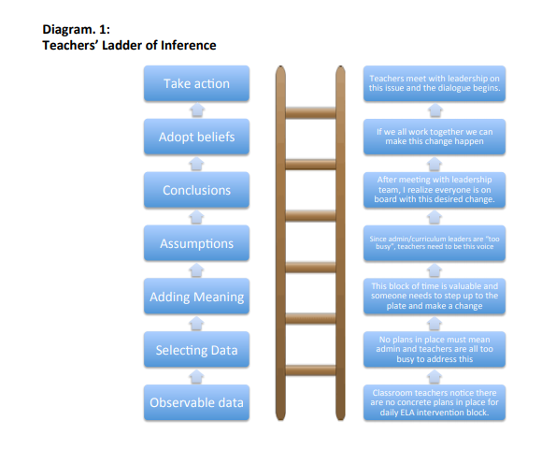

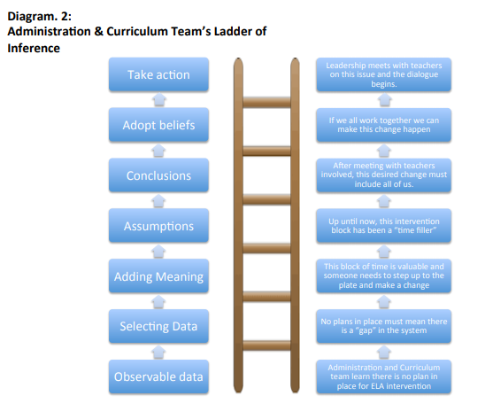
Team Learning Design
Team learning is a continuous process – it involves reaching decisions from time-to-time. Thus, an individual has to be flexible and ready to work on new ideas that seem to be fitting the prevailing conditions. Thus, the group of personnel who will be looking into the issue has to consist of people who are not static. Those involved in the team learning design process, have to work as a team that is determined to reach for a common goal. However, in any kind of discussion group, there will always come up a variety of ideas and opinions, but in a team like this one the members have to have in mind the thought of bettering the learning process.
The first meeting will be attended by all members involved in the reviewing of the learning activities. We shall then review the already existing learning activity and then each member would then contribute towards its strengths, needs, and the necessary changes. This meeting will be flexible enough to assure that all members will contribute their thoughts without being restricted to a particular point.
The following meeting will also not be restricted to any agenda. However, the meeting will entail looking into the possible intervention methods and ideas that every member can advocate for. I will ensure that all main points are captured and displayed on a large board. As the meeting progresses, I will strive to connect the main ideas so that I can show the team members that we can have something good by the end of the entire process. The mapping of the ideas will also ensure as a team, we all stay in line with the main agenda of the meeting – bringing about positive changes in the curriculum.
Apart from overseeing the progress of the discussion during the meeting, I would also highlight the best practices that can involve making changes. Thus, it will be important to have a look at the things that we base on while evaluating the progress of the students (Senge, et al., 2012). In the past, we have been considering a method that I think has been time-consuming, and thus, there is a need to have in place a method that will be effective while at the same time saving on time. With that having been said, I would suggest that we apply the STEP reading assessment and the latest benchmark data. Through the application of both the STEP reading assessment and the latest benchmark data, we shall create a desirable plan for the students. However, we shall always remain flexible ready to make any change that seems to be necessary. Once we have in place a plan, I would then organize the collected data in such a way that, the foundation of the new ELA intervention plan will be laid upon.

References
McGinn, A. (2017). Play-based early childhood classrooms and the effect on pre-kindergarten social and academic achievement.
Senge, P. M., Cambron-McCabe, N., Lucas, T., Kleiner, A., Smith, B., & Dutton, J. (2012). Schools that learn.: a fifth discipline fieldbook for educators, parents, and everyone who cares about education. Knopf Doubleday Publishing Group.

